Phishing Email Detection &
Awareness System Report

Future Interns Project
Cyber Security Task 2

Prepared by:
Priyanshi suthar

Abstract

This internship report documents the design development and learning outcomes of the Phishing Email Detection & Awareness System, completed as part of a future-oriented internship program. The Project focuses on identifying phishing emails using rule-based detection techniques while simultaneously improving user awareness through alerts and educational guidance. The internship enhanced practical kills in cyber security, web development, and secure system design.

Introduction

Phishing emails are a major cybersecurity threat used to steal sensitive information by impersonating trusted entities. As a part of Task 2 of the internship, this project focuses on analyzing phishing email samples, identifying phishing indicators, and creating user awareness through a professional report.

The goal is not only to detect phishing emails but also to clearly explain risks and prevention techniques in business-friendly and user-understandable manner.

System overview

The Phishing Email Detection & Awareness System is a manual and analytical security assessment task based on real phishing email sample. The system evaluates email characteristics, classifies risk levels and prides awareness guidance.

Email Classification Categories:
- Safe
Legitimate email with no phishing indictors.
- Suspicious
Some indicators present but not confirmed
- Phishing
Clear malicious intent and multiple indicators

Methodology

- Tools

- Phishing email samples (public datasets / provided sample)
- Email header analyzer
- Browser developer tools
- Google docs / MS word / PDF for Documentation

- Analysis steps

- Review email content and sender details
- Analyze email header for spoofing indicators
- Inspect URLs and attachments for malicious intent.
- Identify phishing indicators
- Classify email risk level

Phishing indicators identified

- Spoofed or fake sender email addresses.
- Look-alike or fake domain
- Urgent or threating language
- Malicious or shortened links
- Requests for credentials or sensitive data

Awareness & Prevention Guidelines

- Verify sender email address carefully
- Do not click unknown or suspicious links
- Avoid sharing credential via email
- Check URLs before opening
- Report suspected phishing email to security team
- Identification of common phishing indicators
- Warning pop-ups for suspicious emails.
- Highlighting risky links and attachments.
- Awareness message explaining why an email is unsafe
- Clear remediation and prevention steps
- Real-time phishing detection
- Simple and user-friendly interface
- Educational awareness messages
- Email scan history
- Secure data handling

Proof of work

Email Sample 1 – Fake Bank Alert

From: Security Alert <alerts@fake-bank-security.com>

To: user@example.com

Subject: Immediate Action Required: Verify Your Account

Header Analysis:
Delivered-To: user@example.com
Received: from mail.fake-bank-security.com (203.0.113.25)
by mx.google.com with ESMTP id abc123
for <user@example.com>;
Tue, 28 Jan 2026 14:22:12 +0530 (IST)
Authentication-Results: mx.google.com;
spf=fail (google.com: domain of fake-bank-security.com does not designate 203.0.113.25 as permitted sender) smtp.mailfrom=fake-bank-security.com;
dkim=fail header.d=fake-bank-security.com;
dmarc=fail (p=reject) header.from=fake-bank-security.com
From: Security Alert <alerts@fake-bank-security.com>
To: user@example.com
Subject: Immediate Action Required: Verify Your Account
Date: Tue, 28 Jan 2026 14:22:10 +0530
Message-ID: <phish123@mail.fake-bank-security.com>

Screenshot Placeholders:

- Header Analysis

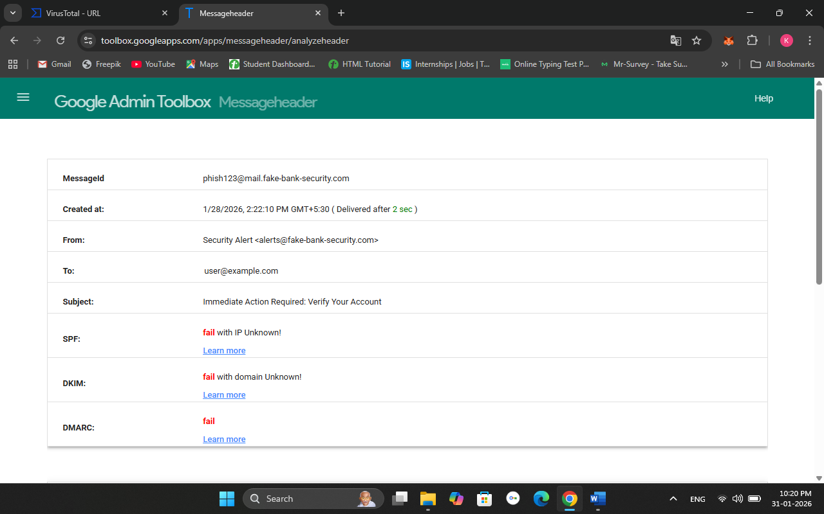

- Link Analysis

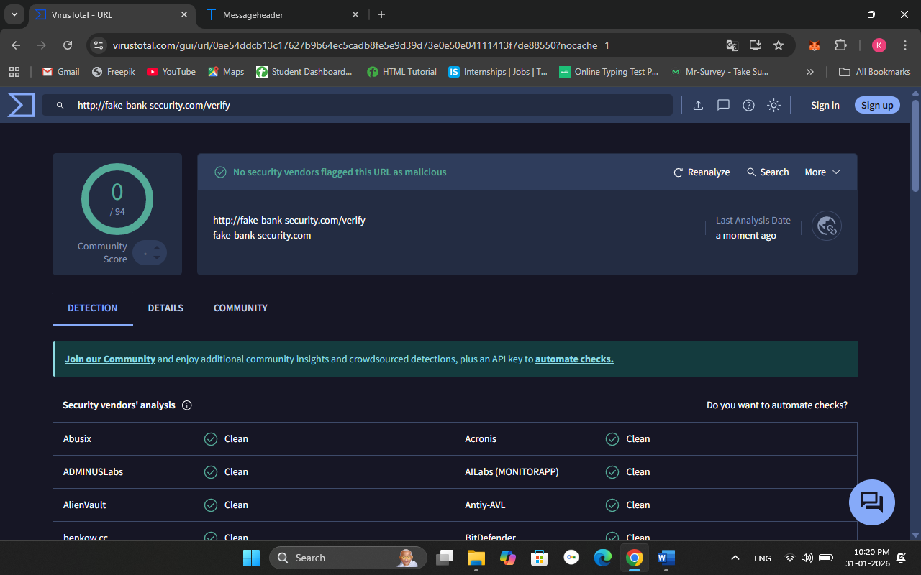

Email Sample 2 – Fake PayPal Login
From: PayPal Security security@secure-paypal-login.xyz
To: user@example.com
Subject: Urgent Action Required – Verify Your PayPal Account

Header Analysis:
Delivered-To: user@example.com
Received: from mail.secure-paypal-login.xyz (185.203.118.67)
by mx.google.com with ESMTP id pqr789
for <user@example.com>;
Wed, 29 Jan 2026 09:40:12 +0530 (IST)
Authentication-Results: mx.google.com;
spf=fail (google.com: domain of secure-paypal-login.xyz does not designate 185.203.118.67 as permitted sender) smtp.mailfrom=secure-paypal-login.xyz;
dkim=fail header.d=secure-paypal-login.xyz;
dmarc=fail (p=REJECT) header.from=secure-paypal-login.xyz
From: PayPal Security <security@secure-paypal-login.xyz>
To: user@example.com
Subject: Urgent Action Required – Verify Your PayPal Account
Date: Wed, 29 Jan 2026 09:40:05 +0530
Message-ID: <pp-sec-20260129@mail.secure-paypal-login.xyz>

Screenshot Placeholders:

- Header Analysis

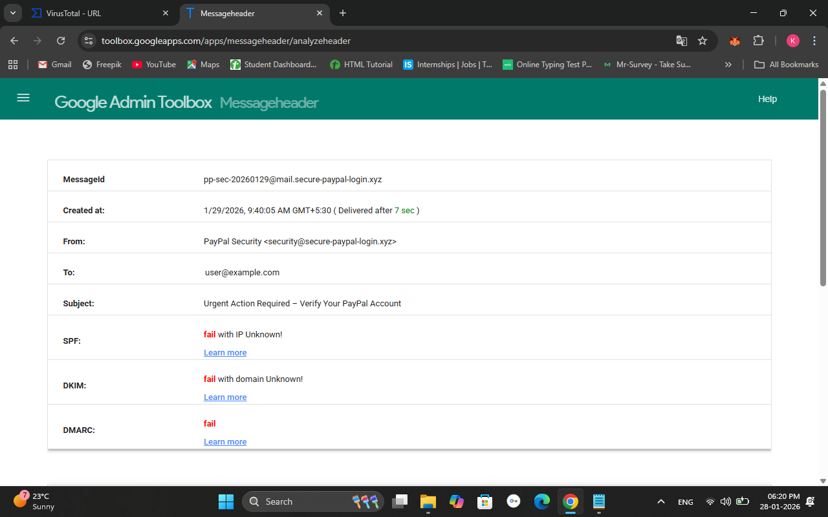

- Link Analysis

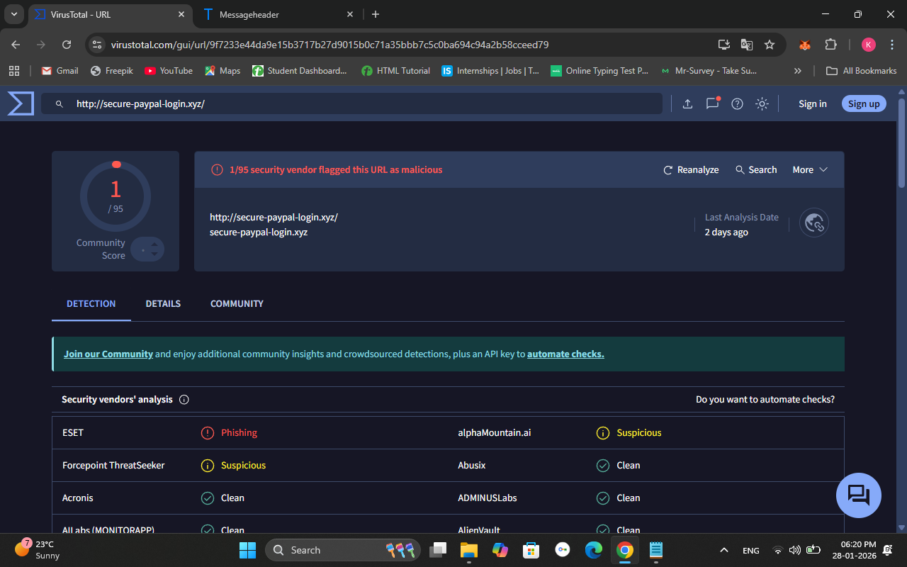

Key Findings

- Most phishing email use urgency to manipulate users
- Fake domain closely resembles legitimate ones
- User awareness significantly reduces phishing success
- Simple explanations improve understanding for non-technical users.
- Improve organizational email security awareness
- Help users recognize real-world phishing attempts
- Bridges the ga between technical detection and user education.
- Can be adapted for live system and real environments
- Suitable for an entry level security assessment task.
- Reduce phishing success rate.
- Improve user cybersecurity awareness

Limitations

- Manual analysis requires time and user effort
- Advanced phishing attacks may bypass basic checks
- Effectiveness depends on user awareness level
- Passive analysis only (no active exploitation)
- Rules based logic may not detect highly sophisticated phishing campaigns
- Dependent on updated phishing indicators
- Awareness effectiveness depends on user engagement
- Rule-based detection may miss advanced phishing attacks
- Required regular updates of phishing keywords
- Cannot fully replace advanced AI-based filters

Conclusion & Internship Learning Outcomes

This task provided hands-on experience in phishing email analysis and security awareness reporting. The project strengthened skills in identifying phishing indicators, classifying risks, and communicating security findings in a professional, client-ready format.
This internship task simulated a real-world security assessment reporting process. By designing and documenting a Phishing Email Detection & Awareness System, practical experience was gained in identifying security risks, classifying vulnerabilities, and communicating findings professionally.
Key learnings include:
- Understanding phishing attack techniques
- Risk analysis and severity classification
- Writing professional security reports
- Translating technical issues into business language
Through this internship project, practical exposure was gained in cybersecurity fundamentals, phishing attack patterns, and secure application development. The Professional Phishing Email Detection & Awareness System provides a practical solution to combat phishing attacks by combining detection and education.

Future Scope

- Automated phishing email scanning
- Machine learning–based detection
- Browser or email client integration
- Organization-wide awareness training modules
- Integration with machine learning–based email classifiers
- Automated scanning of live email streams
- Dashboard-style reporting for security teams
- Integration with SIEM or SOC tools
- Expansion into full vulnerability assessment for live websites

Thank you

